Title: Bold 14pt Times New Roman or Mincho, 16 pt,
no more than three lines including the subtitle,
each line should be 35 characters or less

Group name: Within one line, 11pt. Times New Roman or Mincho, 14pt. line spacing
Student name ¹⁾: 11pt font, 14pt line spacing, and indicate affiliation by a superscript number with single parenthesis. If there are co-presenters, list the names as Student Name ¹⁾, Student Name ¹⁾, within two lines.
Name of instructor¹⁾, name of research collaborator ²⁾: 11pt. font, 14 pt. line spacing, within one line.

1) Affiliations: 11pt font, 14pt line spacing, list the university name, faculty, department and laboratory in order. 2) List them in line numbers
3) The affiliation should be within three lines. 4) If necessary, use two or three columns.

Keywords: 10 pt. in Times New Roman font, 14 pt. line spacing, 10 characters or less per word, up to 5 keywords.
The total number of characters should be 35 or less, within two lines, centered and each words should be separated by ","

1. Notes
When you apply for a presentation, the parts from the title to the keywords are the items to be entered in the application form. Please make sure that the information in the abstract (2 pages in A4 size) and the application form (entered directly on the website) do not differ. Please complete the abstract and then copy and paste the applicable part to the application form. If necessary, please transcribe the necessary information from the abstract to the "Check Sheet" (Form 2) and then enter it in the application form.

2. Form and formats
The presentation theme, names, affiliations, main text, etc. can be created by overwriting this file (MS Word file). Please use this file as much as possible. If you wish to set up your own format, please use the following format.
The paper should be A4 size, written horizontally or vertically, within two pages including figures and tables. The margins should be 25 mm (top and bottom) and 20 mm (left and right). The part 40 mm x 40 mm from the top left corner of the paper should be left blank where the presentation number will be inserted by the secretariat. The first section from the title to the keywords should be in one column with the maximum of 50 characters and 40 lines. The later body part should be in two columns with the maximum of 21 characters and 40 lines.

3. The number of lines and font and line spacing requirements for the title, etc.
The font of the first section from the title to the keywords should be (Times New Roman or Mincho). The font size should be (14pt for the title, 12pt for the subtitle, 11pt for the group name, names and affiliations, and 10pt for the keywords). As for the number of lines and formatting for the sections from the title to the keywords, follow the above instructions. The line spacing (for Word, the setting is available in "Paragraph") should be fixed at 16pt for the title and 14pt for the rest. The title should be within 3 lines including the subtitle, the group name should be within 1 line. The names of presenter and co-presenters should be within 2 lines and they should be separated by ",". The name of instructor and research collaborator should be listed together within one line. The affiliations of each individual should be indicated with superscript numbers in single parenthesis. The specific affiliations should be listed in line numbers in single parenthesis. Since there is a limit of three lines for the affiliation paragraph, make it into two or three columns as necessary. Please refer to the following example for the formatting of the names and affiliations. Key words should be no more than 35 characters, excluding "," between words, and no more than two lines.
The number of lines and characters in the body can be set arbitrarily, but the font should be Times New Roman or Mincho 10pt. Please leave two blank lines between the keywords and the body.

4. The text style of the main body
The style of the body is up to your choice, and bold or gothic type may be used for headings such as words, methods, results, discussions, proposals, and conclusions. Bold or gothic type may be used for the titles of figures and tables as well.

5. Names and affiliations
If all presenters, co-presenters and teachers have the same affiliation, there is no need to include the numbers in single parenthesis after the names and before the affiliation (see example 1 below). On the other hand, if any of the presenters, co-presenters or instructors has a different affiliation from that of a presenter, add a number and single parenthesis to the upper right corner of each name to indicate the affiliation, and add a number and single parenthesis before the list of affiliations (see Example 2 below).
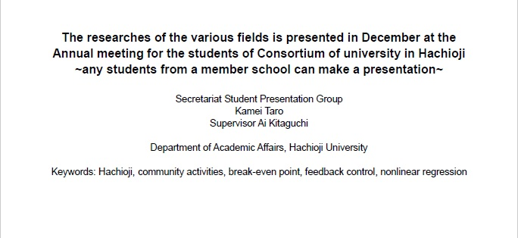
Example 1) If all the presenter, co-presenter and instructor belong to the same institution

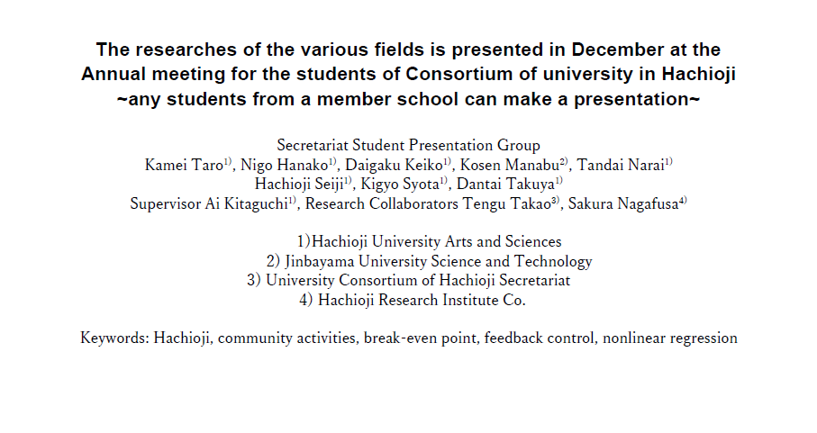Example 2) If any of the presenters, co-presenters or instructors has a different affiliation from that of a presenter.

6. Submission of the abstract
The file format for sending the abstract is PDF. The file name should be "institution’s name_presenter’s name" (in alphabet).
Example: "kougakuin_Yamada Taro".

工学院大学→kougakuin 明星大学→meisei
東京工業高等専門学校→tokyokousen
帝京大学→teikyo
帝京大学短期大学→teikyotanki
東京造形大学→tokyozoukei
東京純心大学→tokyojunsin
杏林大学→kyorin 多摩美術大学→tamabi
創価大学→soka 創価女子短期大学→sokajosi
東京薬科大学→tokyoyakka
拓殖大学→takusyoku 中央大学→chuo
日本文化大學→nihonbunka 法政大学→hosei
東京工科大学→tokyokouka
東京都立大学→tokyotoritsu
山野美容芸術短期大学→yamano
ヤマザキ動物看護大学→yamazaki
東京家政学院大学→tokyokasei
サレジオ工業高等専門学校→salesio
デジタルハリウッド大学→dejihari
桜美林大学→obirin 多摩大学→tama

